TITLETITLETITLE

Authorship (do not include in pre-evaluation version)
Affiliation (do not include in pre-evaluation version)
ORCID (do not included in pre-evaluation version)
Email (do not include in pre-evaluation version)

Date of receipt: day/month/year / Date of acceptance: day/month/year

Abstract (200-300 words)

Keywords (4-6 words)

[es] TÍTULOTÍTULOTÍTULO

Resumen (200-300 palabras)

Palabras clave (4-6 palabras)

1. Section 1
Times New Roman 12 pt. Single line spacing (1.15). Justified alignment on both sides. First-line indentation of 1 cm, except for paragraphs that begin a new section (heading, subheading) and those following a long quotation or image. Regarding the length of submissions, articles and introductory chapters of monographic issues should contain between 7,000 and 9,000 words in total (including references, footnotes, tables, graphs, etc.). Reviews should range between 2,000 and 4,000 words in total. Short quotations (fewer than 40 words): enclosed in quotation marks in the following order: guillemets (« »), double quotation marks (“ ”), single quotation marks (‘ ’). Example: «This is a short quotation. This is a short quotation» (Author page).
Times New Roman 12 pt. Single line spacing (1.15). Justified alignment on both sides. First-line indentation of 1 cm, except for paragraphs that begin a new section (heading, subheading) and those following a long quotation or image. Regarding the length of submissions, articles and introductory chapters of monographic issues should contain between 7,000 and 9,000 words in total (including references, footnotes, tables, graphs, etc.). Reviews should range between 2,000 and 4,000 words in total. Short quotations (fewer than 40 words): enclosed in quotation marks in the following order: guillemets (« »), double quotation marks (“ ”), single quotation marks (‘ ’). Example: «This is a short quotation. This is a short quotation» (Author page).

Quotations longer than 40 words: Times New Roman 11, left indentation of 1 cm, justified alignment on both sides, single line spacing. Quotations longer than 40 words: Times New Roman 11, left indentation of 1 cm, justified alignment on both sides, single line spacing. Quotations longer than 40 words: Times New Roman 11, left indentation of 1 cm, justified alignment on both sides, single line spacing. Quotations longer than 40 words: Times New Roman 11, left indentation of 1 cm, justified alignment on both sides, single line spacing. Quotations longer than 40 words: Times New Roman 11, left indentation of 1 cm, justified alignment on both sides, single line spacing. (Author page)

Times New Roman 12 pt. Single line spacing (1.15). Justified alignment on both sides. First-line indentation of 1 cm, except for paragraphs that begin a new section (heading, subheading) and those following a long quotation or image. Regarding the length of submissions, articles and introductory chapters of monographic issues should contain between 7,000 and 9,000 words in total (including references, footnotes, tables, graphs, etc.). Reviews should range between 2,000 and 4,000 words in total. Short quotations (fewer than 40 words): enclosed in quotation marks in the following order: guillemets (« »), double quotation marks (“ ”), single quotation marks (‘ ’). Example: «This is a short quotation. This is a short quotation» (Author page).
Images must include a caption, as indicated (Fig. 1). The image must have a resolution of 300 ppi, and the caption should be in Times New Roman, 10 pt. Additionally, the rights to reproduce the image must be secured, and this information should be included in the same caption. The responsibility for obtaining these rights and covering any associated reproduction costs, if applicable, lies with the author of the text.

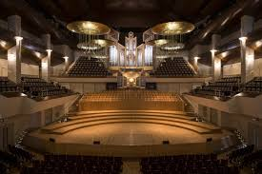
Fig. 1. General view of the National Auditorium, Madrid, 2024. Courtesy of the National Auditorium.

In the case of an artwork, the authorship of the piece, the title in italics, and the year must also be included. Additionally, the appropriate reproduction rights must be secured:

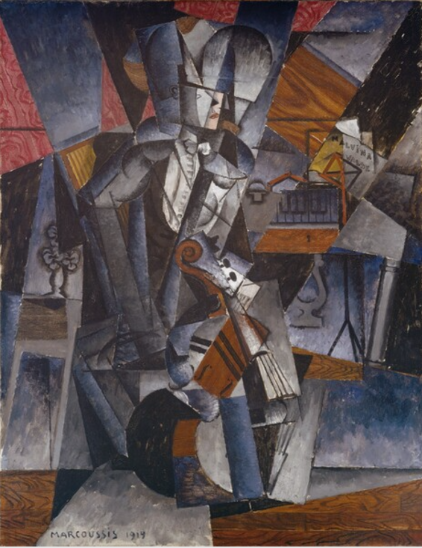
Fig. 2. Marcoussis, The Musician, 1914, National Gallery of Art, Washington. Courtesy of the National Gallery of Art.

1.1. Subsection 1
1.2. Subsection 2

2. Section 2

3. Section 3
Acknowledgements
Do not include in the pre-evaluation version. Times New Roman, 12 pt. Single line spacing. Justified alignment on both sides. Do not include in the pre-evaluation version. Times New Roman, 12 pt. Single line spacing. Justified alignment on both sides.

References
Hanging indent at 0.5 cm. In the latest version of MLA. Times New Roman, 12 pt. Single line spacing. Justified alignment on both sides. Hanging indent at 0.5 cm. In the latest version of MLA. Times New Roman, 12 pt. Single line spacing. Justified alignment on both sides.
Hanging indent at 0.5 cm. In the latest version of MLA. Times New Roman, 12 pt. Single line spacing. Justified alignment on both sides. Hanging indent at 0.5 cm. In the latest version of MLA. Times New Roman, 12 pt. Single line spacing. Justified alignment on both sides.
Hanging indent at 0.5 cm. In the latest version of MLA. Times New Roman, 12 pt. Single line spacing. Justified alignment on both sides. Hanging indent at 0.5 cm. In the latest version of MLA. Times New Roman, 12 pt. Single line spacing. Justified alignment on both sides.



Footnotes: Times New Roman, 10 pt. Single line spacing. No indentation. Justified alignment on both sides. Use Arabic numerals in superscript, and when applicable, place them before punctuation marks. Footnotes: Times New Roman, 10 pt. Single line spacing. No indentation. Justified alignment on both sides. Use Arabic numerals in superscript, and when applicable, place them before punctuation marks. Footnotes: Times New Roman, 10 pt. Single line spacing. No indentation. Justified alignment on both sides. Use Arabic numerals in superscript, and when applicable, place them before punctuation marks.

